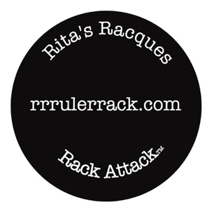

**Rita’s Racques**

[www.rrrulerrack.com](http://www.rrrulerrack.com)

612-816-7131

ritasracques@gmail.com

ritasracques@gmail.com

**Tools needed:**

Standard 24” level

3/8” box end open and or adjustable wrench

Pencil

Hammer

2 small headed nails

**Directions**: Determine the desired location. Bring the level to a horizontal position. Make pencil marks 24” apart for the large rack, 12” apart for the Junior rack. Pound the nails slightly downward. Screws can be used (#6 wood screws) with plastic anchors for heavy loads in drywall.

The rack has RRR sticker on the back of the right bottom side. In each hole on the bottom, insert the machine screw and spacer from the back, through the rack and tighten securely with the front decorative cap. In each hole on the top, insert the machine screw (with attached hanger) and the spacer in the same manner as above. Tighten the top screws moderately tight so the hangers can swivel to align themselves. Slide hooks into the slots. Adjust hooks to the width of the rulers you are hanging. You can mount up to 7 rulers on each hook.

**Contents**:

Rack Body

2 machine screws for the bottom holes

2 machine screws with hanger attached for the top holes

4 nylon spaces

Metal hooks (6 for the large rack; 4 for the Junior rack